**ECE Capstone Project**

**GreenBox**

**Zach Wilcox**

**Zacdwil@hotmail.com**

**Spring 2022**



**Table of Contents**

1. Executive Summary 2

2. Introduction 3

3. Methods 3

4. Results 3

5. Discussion 4

6. Conclusion 4

# Executive Summary

The executive summary provides an overview of the content contained in the report. Many people write this section after the rest of the document is completed. This section is important in that it provides a high-level summary of the detail contained within the rest of the document.

# Introduction

### **Purpose**

From the very early stages of humankind, people have been raising and caring for plants due to their many benefits. Plants help us in a wide range of ways, from providing the food necessary to live to creating a pleasant ambiance in a living room. Unfortunately, raising and caring for plants can be quite difficult for those without a “green thumb,” like myself. The GreenBox project’s purpose is to help make raising and caring for all sorts of plant life more approachable for everyone.

### **Objectives**

The overall objective of this project was to create a space with moderated temperature, humidity, air flow, and light exposure. Specifically, the GreenBox should be able to do the following:

* Measure the temperature and humidity in the chamber with 95% or greater accuracy.
* Adjust the temperature up or down as needed to bring it into the desired range as needed.
* Adjust the humidity up or down as needed to bring it into the desired range as needed.
* Turn on the lights for the desired amount of time each day.
* Turn on the fans for the desired amount of time each day.
* Show the current temperature and humidity levels on a display.

### **Approach**

The technology of environmental control is not an incredibly recent development, so my approach was to make a system using a microcontroller that would be able to control all these already existing systems in one space. It would do this by controlling the power supply to each subsystem, making it a control system that could be scaled to meet the needs of the user. However, for the purpose of this project a non-scalable, desktop-sized version was made.

# Methods

There were two methods used to monitor what needed to be adjusted: timers and sensors. The fans and lights were toggled on and off based on a timer that could be adjusted by the user input. (Note: the fans were originally going to be controlled by a CO2 sensor, but due to high complexity and time constraints were moved to a timer-based control function.) The temperature and humidity were controlled by comparing the sensor values to the user’s input values. Due to plants not needing extreme precision in temperature and humidity, the sensor was set to get a reading every 30 seconds.

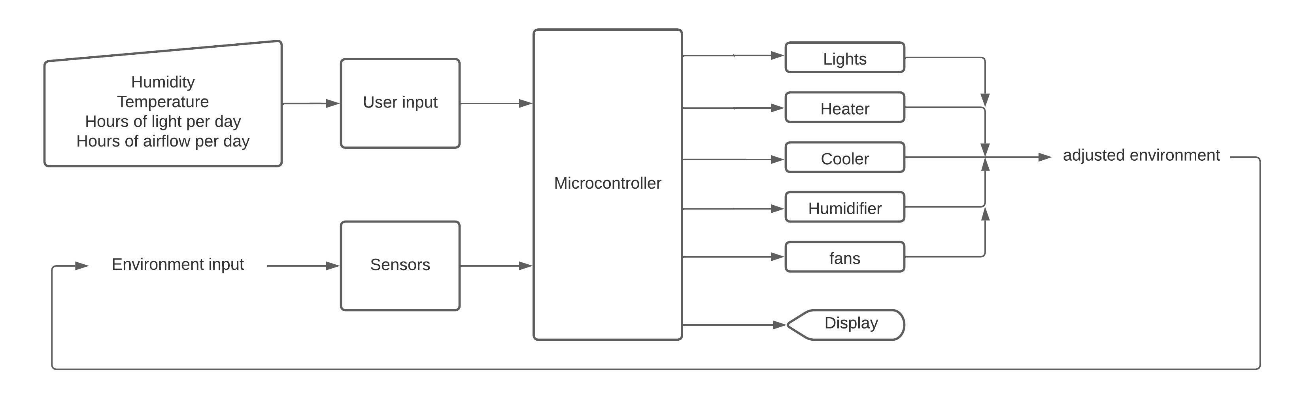

**Figure 1.** Block diagram of the system.

As stated above, the toggling of the systems was accomplished by turning the power supply on and off for each subsystem. This was accomplished using 5V relays and a control signal from the microcontroller. To ensure that each component got the correct power supply while simplifying the user experience, a power strip and an AC/DC converter were used to power all components including the microcontroller.

Though very inefficient, a Peltier cooling system was used due to a combination of low cost and the ability to do some light dehumidifying, unlike the originally intended evaporative cooler. To get a humidifier that would fit into the design, a custom-built wicking humidifier was used as opposed to a commercially sold one. For heating, a small commercial space heater was used as it was very simple and cost-effective. For similar reasons, an LED light strip was used for lighting. The fans used were basic PC fans.

The box build was originally going to be made of wood and sheet metal due to the ease of assembly and low cost. However, it was decided that the product would be more aesthetic and durable if clear acrylic and sheet metal were used. The original 2’x2’x2’ design was slightly modified to have a sloping front face to allow the door to sit in the closed position using gravity.

In the specifications document, it states that there will be two knobs for each environmental factor, one for the input level and one for how much the actual level was allowed to vary from the input level. However, it was decided that a set level of 5% error would be allowed for all factors, reducing the complexity of the user interface.

# Results

This section describes the results from your testing.

* This is where you present the results (especially testing results) that you got.
* Use graphs and tables if appropriate, but also summarize your main findings in the text.
* **Do NOT discuss the results or speculate as to why something happened; that goes in the Discussion section.**
* You don't necessarily have to include all the data you've gotten during the semester. This isn't a diary, just a report of final results.
* Use appropriate methods of showing data. Don't try to manipulate the data to make it look like you did more than you actually did.

# Discussion

This section discusses the implications of your test results and of your project overall.

* Highlight the most significant results, but don't just repeat what you've written in the Results section.
* How do these results relate to the original problem?
* Does the data suggest that your solution worked?
* Are your results consistent with what other engineers have reported? If your results were unexpected, try to explain why. Is there another way to interpret your results?
* What further research would be necessary to answer the questions raised by your results?
* How do your results fit into the big picture?
* End with a one-sentence summary of your conclusion, emphasizing why it is relevant.

# Conclusion

This section should discuss what you learned from doing this project.